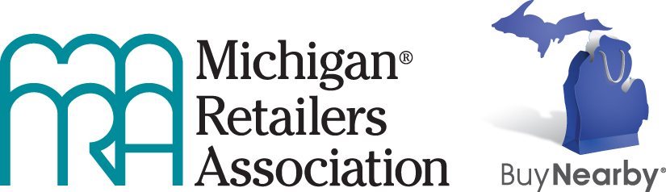

Buy Nearby 2017 Fact Sheet

The Buy Nearby campaign is an ongoing, year-round, feel-good campaign intended to create excitement about the great shopping in Michigan and the advantages of supporting retailers and communities in Michigan. You can think of it as a “shop local” campaign for the entire state. The campaign is designed to get everyone excited about the great places and great shops in Michigan and get shoppers committed to buying in Michigan.

The campaign runs throughout the year and is formally celebrated on the first weekend in October, called “I Buy Nearby Weekend.” The two-day special shopping weekend, which this year falls on Oct. 7-8, will include a drawing for a $500 gift card to one lucky shopper who posts a photo of buying nearby with the hashtag #ibuynearby.

In addition to promoting the fun and value of shopping at Michigan retail businesses, the Buy Nearby campaign is designed to be an economic driver for the state.

About half of every dollar spent in a Michigan store goes back into the local and Michigan economies. (Source: 2004 Andersonville Study of Retail Economics).

More than 866,000 Michigan jobs are directly dependent on retail sales. (Source: PricewaterhouseCoopers LLP, the economic Impact of the U.S. Retail Industry, August 2011)

If Michigan consumers chose to support businesses in Michigan by always buying nearby rather than from out-of-state retailers that don’t invest here, Michigan would gain some 75,000 additional jobs and $9 billion in additional economic activity, including $2.5 billion in additional wages the new workers would earn. (Source: Anderson Economic Group, Economic Costs of Untaxed Remote Sales and Potential Benefits of “Buy Nearby,” July 2014)

If Michigan consumers switched only one in 10 of their purchases from “remote” merchants to Michigan businesses, Michigan still would gain more than $900 million in increased economic activity and 7,500 new jobs. Switching one in five purchases would mean more than $1.8 billion in increased economic activity and 15,000 new jobs. (Source: Anderson Economic Group, Economic Costs of Untaxed Remote Sales and Potential Benefits of “Buy Nearby,” July 2014)

More than 18 percent of Michigan’s total economic activity (GDP) comes from the retail sector, and 17 percent of Michigan’s labor income comes from retail jobs. (Source: PricewaterhouseCoopers LLP, the economic Impact of the U.S. Retail Industry, August 2011)

Shoppers and retailers are encouraged to use social media to post photos and comments during “I Buy Nearby Weekend,” as well as throughout the year, about their great experiences when they Buy Nearby.

The Buy Nearby campaign was created by the Michigan Retailers Association and launched in April 2013. The 2017 campaign is sponsored by DTE Energy (title sponsor) and Retailers Insurance Company (supporting sponsor). Contributions to the campaign can be made on the Buy Nearby website at www.BuyNearbyMI.com.

Additional information is available at www.BuyNearbyMI.com, www.facebook.com/BuyNearbyMI, and www.twitter.com/BuyNearbyMI.

