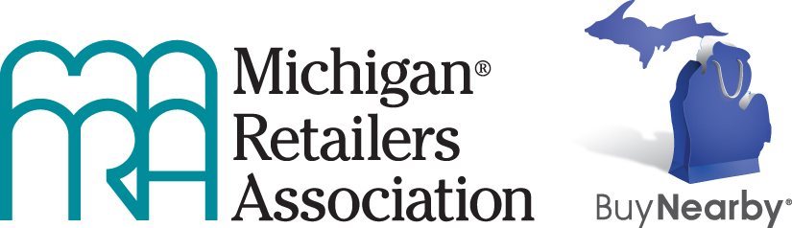

Buy Nearby 2018 Fact Sheet

The Buy Nearby campaign is a shop local initiative to create excitement about the great shopping in Michigan and the advantages of supporting retailers and communities in our state.

The campaign runs throughout the year and is formally celebrated on the first weekend in October, called “I Buy Nearby Weekend,” which is Oct. 5-7, 2018. The special shopping weekend will include a contest to get shoppers into participating retailers’ stores.

Our mascot, Buy Nearby Guy, is a shopping bag in the shape of Michigan. He’s a popular fixture at festivals, parades and farmers markets around Michigan. You can follow him on Twitter (@buynearbymi).

The official hashtag: #buynearbymi – which matches our website, buynearbymi.com. You can also find us on Facebook (fb.com/buynearbymi) and Instagram (@mibuynearby).

Here are some facts about the impact of “buying nearby”:

- In addition to promoting the fun and value of shopping at Michigan retail businesses, the Buy Nearby campaign is designed to be an economic driver for the state. About half of every dollar spent in a Michigan store goes back into the local and Michigan economies.

- More than 866,000 Michigan jobs are directly dependent on retail sales. (Source: PricewaterhouseCoopers LLP, the economic Impact of the U.S. Retail Industry, August 2011)

- If consumers chose to support businesses in Michigan by always buying nearby rather than from out-of-state retailers that don’t invest here, Michigan would gain some 75,000 jobs and $9 billion in additional economic activity, including $2.5 billion in additional wages the new workers would earn. (Source: Anderson Economic Group, Economic Costs of Untaxed Remote Sales and Potential Benefits of “Buy Nearby,” July 2014)

- If Michigan consumers switched only one in 10 of their purchases from “remote” merchants to Michigan businesses, Michigan would gain more than $900 million in increased economic activity and 7,500 new jobs.

- More than 18 percent of Michigan’s total economic activity (GDP) comes from the retail sector, and 17 percent of Michigan’s labor income comes from retail jobs. (Source: PricewaterhouseCoopers LLP, the economic Impact of the U.S. Retail Industry, August 2011)

The Buy Nearby campaign was created by the Michigan Retailers Association and launched in April 2013. The 2018 campaign is sponsored by DTE Energy (title sponsor) and Retailers Insurance Company (supporting sponsor).

